# Preparation:

# The machine name is Homework27112024. It is standalone,

# so Default Switch will provide the network connection

# So on the host we run the following sequence of commands:

Set-VMProcessor -VMName Homework27112024 -ExposeVirtualizationExtensions $true

Set-VMMemory -VMName Homework27112024 -DynamicMemoryEnabled $false

Set-VMNetworkAdapter -VMName Homework27112024 -MACAddressSpoofing on

# Checking free ram on my machine. It is 6.4 of 11.8, so 4096 will do the job

# When the server is ready the next command is in its powershell:

Install-WindowsFeature -Name Hyper-V -IncludeManagementTools -Restart

# After the restart we proceed with the docker installation:

Invoke-WebRequest -Uri https://get.mirantis.com/install.ps1 -o install.ps1

Set-ExecutionPolicy -ExecutionPolicy RemoteSigned -Force -Scope Process

.\install.ps1

# check installation:

Get-Service containerd,docker

# Task 1:

docker run -d -p 9000:80 mcr.microsoft.com/windows/servercore/iis

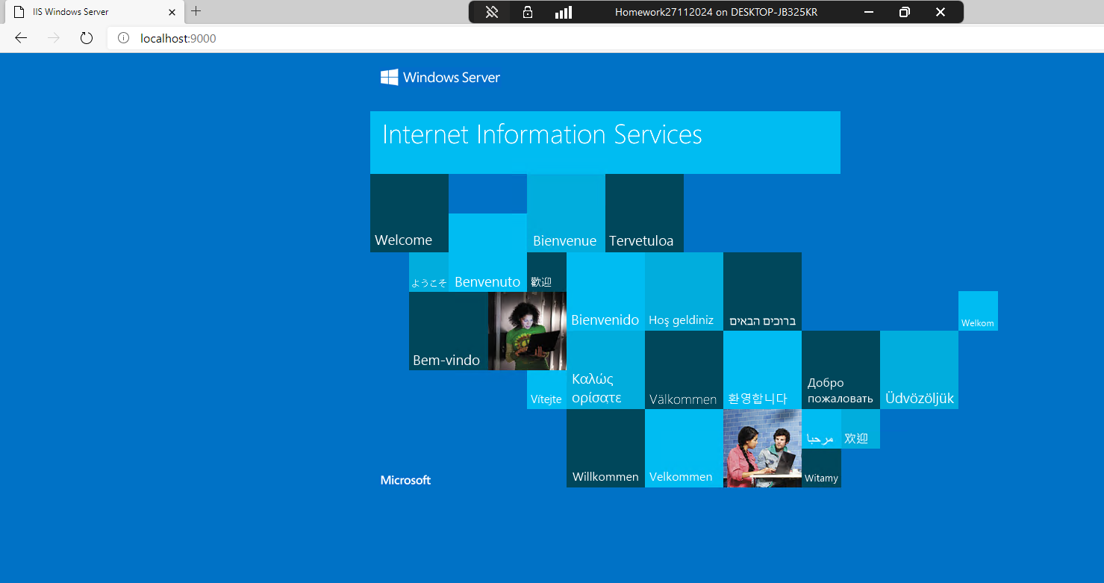

# Task 2:

mkdir C:\docker-images\web

cd C:\docker-images\web

notepad index.html

# add text and image

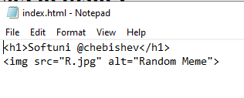

# return to docker-images folder and create Dockerfile

# build the image:

docker image build -t homerwork-iis:v1

# check if the image exists

docker image ls

# Run the image on port 8080

docker run -d -p 8080:80 homework-iis:v1

# Check localhost:8080

